**G H Patel College Of Engineering & Technology**

**(A Constituent College Of CVM University)**

**Bakrol, Vallabh Vidhyanagar**

**COMPUTER ENGINEERING DEPARTMENT**

**Seminar Report**

**On**

***Resort Management System***

**Submitted By**

**Meet Dadhaniya (12202040501038)**

**Param Dholakia (12202040501049)**

**Project Overview:**

This project is a web-based application developed to streamline the management of resort bookings and improve user experience through an accessible and responsive interface. The system is designed to allow users to book rooms, view room details, and communicate with resort management directly. It also enables resort managers to efficiently handle room assignments, review customer bookings, and manage user reviews, creating a comprehensive solution for resort administration.

**Technologies Used:**

Frontend: HTML for structure, CSS for styling, and JavaScript for interactivity.

Backend: PHP for server-side processing, handling form submissions, user authentication, and dynamic data retrieval.

Database: MySQL to store user information, book data, TBR lists, and contact submissions.

**Key Functionalities and Features:**

**Homepage (index.php):**

* **Welcome Banner**: Visitors are greeted with a banner showcasing the resort's luxury accommodations. An introductory message invites them to book a memorable stay, and a call-to-action button, "Book Now," directs them to the booking page.
* **Featured Rooms Section**: Displays popular room options (e.g., Deluxe Room, Presidential Suite) with images, descriptions, and key amenities. Users can click to learn more or proceed to booking.
* **CSS and JavaScript Effects**: Interactive elements, like animated room cards and hover effects, enhance user engagement on the homepage, creating an inviting experience.

**Room Categories (room.php):**

* **Room Type Display**: Various room types, such as Single Room, Double Room, and Suite, are visually represented with images and descriptions. Each room card provides details about amenities, allowing guests to choose the best fit for their needs.
* **Interactive Room Cards**: Cards are designed to display details on hover and link to individual room pages where users can check availability and book. Each card is animated to provide a subtle zoom-in effect on hover, thanks to CSS animations.

**Booking Management (booking.php):**

* **Booking Form**: Users can fill out a booking form, specifying room type, dates, and personal details. The backend processes and validates this data to create a reservation.
* **Confirmation and Storage (assignroom.php)**: PHP scripts validate the booking information and store it in the database. Users receive a confirmation message after a successful reservation, improving their booking experience.
* **Backend Processing**: PHP scripts manage and verify all booking details and store valid bookings securely in the MySQL database.

**Contact Page (contact.php):**

* **Contact Form**: Allows users to reach out for inquiries or special requests. The form includes fields for name, email, subject, and message.
* **Backend Handling (msg.php)**: PHP handles form submissions, validates inputs, and stores messages in the database for easy management by resort staff. A success message is displayed upon successful submission.

**Managerial View (managerview.php):**

* **View Bookings**: Managers can view all current bookings, with details like guest names, room types, and booking dates. This section helps staff organize and allocate rooms efficiently.
* **Room Assignment**: Managers can assign rooms to guests directly from this interface, ensuring smooth operations. Once a room is assigned, the system updates the room’s availability status.

**User Authentication and Management:**

* **Login and Registration (login.php and registration.php)**: New users can create accounts, while returning users log in to manage bookings. PHP securely hashes passwords before storing them in the database.
* **Session Management (logout.php)**: Upon logout, sessions are cleared, and all session variables are removed to protect user data and maintain privacy.

**User Reviews (review.php):**

* **Review Submission**: Users can leave feedback on their stay. Reviews include a rating and a comment section for guests to share their experiences.
* **Review Display (mreview.php)**: Managers can view user reviews, allowing them to monitor guest satisfaction and gather insights for improving services.

**Database Management (connect.php):**

* **Secure Connections**: The connect.php file establishes a secure connection to the MySQL database and ensures data integrity with input validation to protect against SQL injection.

**JavaScript Functionalities**

* **Interactive Room Cards (script.js)**: JavaScript enables the smooth display of room details, handling transitions and creating a dynamic browsing experience.
* **Form Validation (form_validation.js)**: Ensures all required fields in booking and contact forms are correctly filled before submission, improving user experience and data accuracy.

**Styling (style.css)**

* **Consistent Design**: A calm color palette (ocean blues, sandy neutrals) reflects the resort theme, with typography and buttons styled to match the brand’s luxurious ambiance.
* **Responsive Layout**: The layout adapts to various devices, providing a seamless experience across mobile, tablet, and desktop.
* **Interactive Elements**: Hover effects, smooth transitions, and animations enhance elements like room cards, buttons, and forms, adding an elegant touch to the user interface.

**Conclusion**

**Resort Management Web Application** is a robust platform that simplifies the resort booking process for guests and aids resort staff in efficiently managing room assignments and bookings. The project successfully combines frontend and backend technologies to create a secure, interactive, and user-friendly application. The use of MySQL and PHP enables smooth data handling and secure transactions, while the thoughtfully designed interface enhances user engagement.

**Future Enhancements** could include adding a payment gateway for direct booking payments, email notifications for booking confirmations, and an analytics dashboard for managers to view booking trends and improve service offerings.

**WEBSITE INTERFACE OVERVIEW**

* 1. HOME PAGE

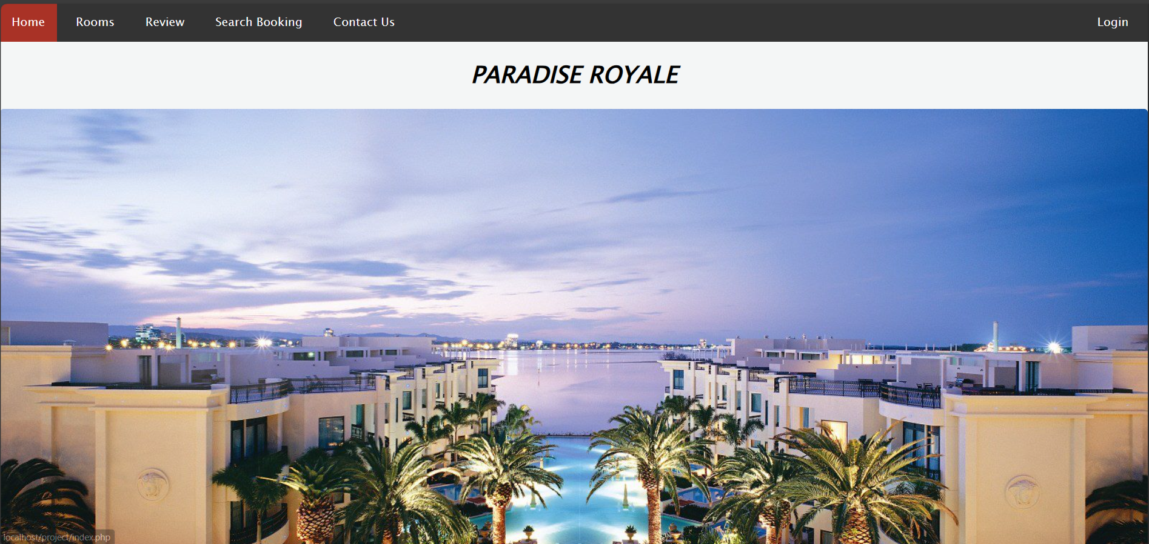

* 1. ROOMS

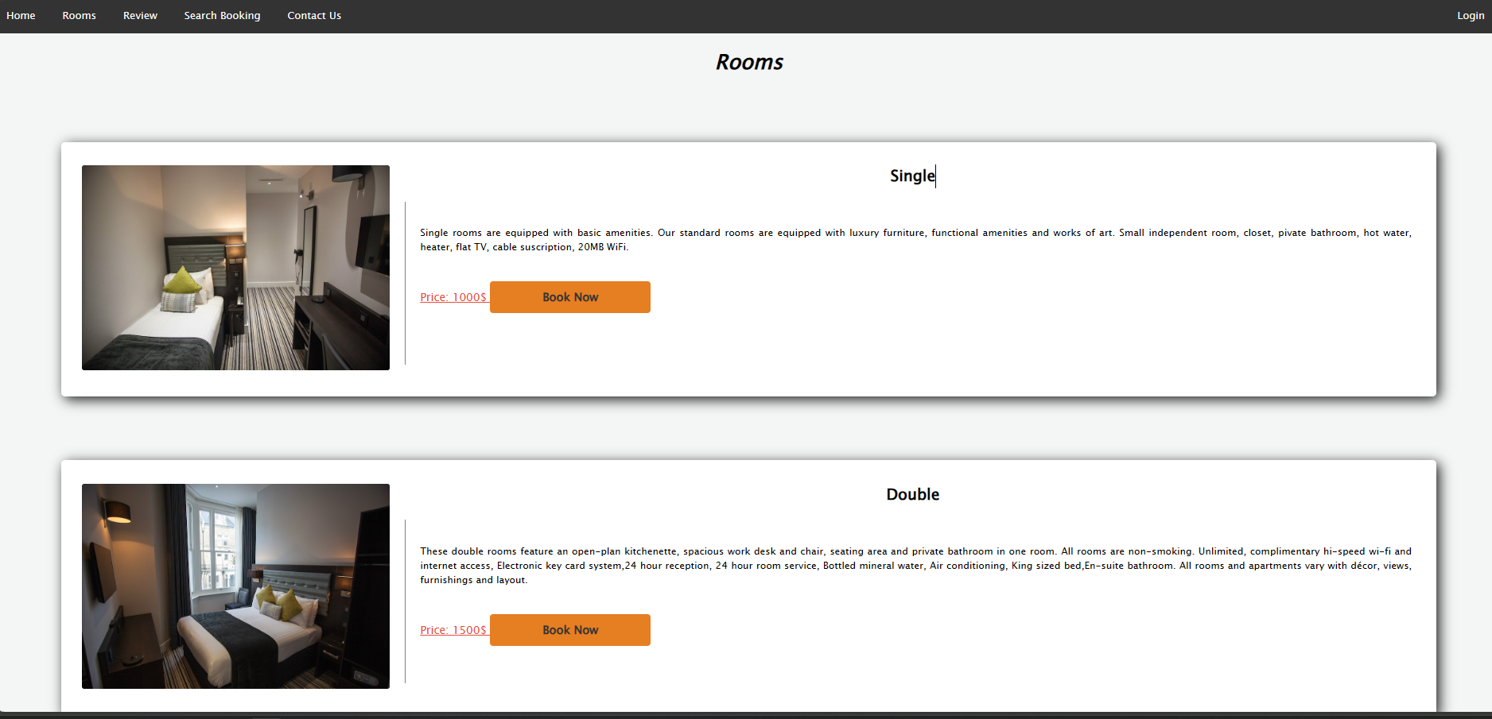

* 1. CONTACT US

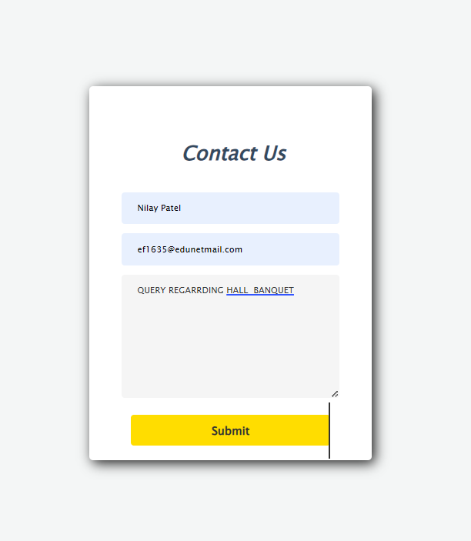

* 1. REVIEW

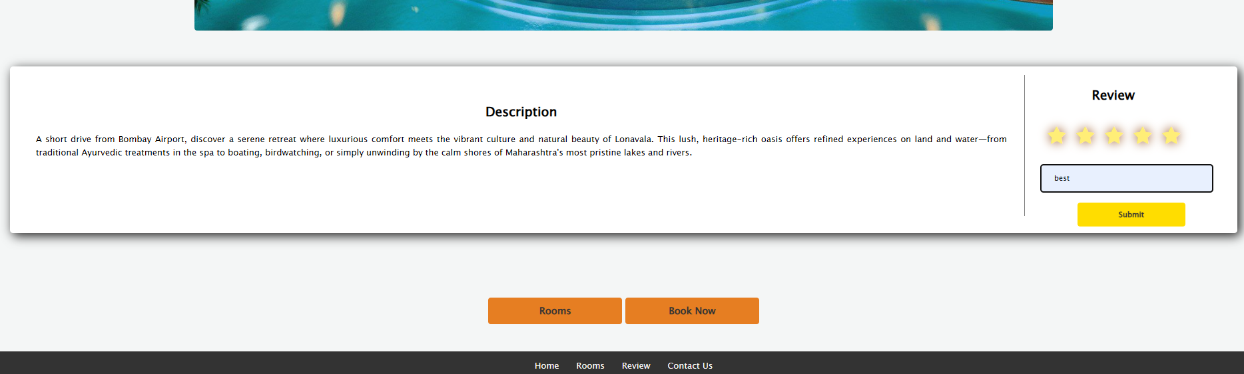

* 1. AMIN LOGIN

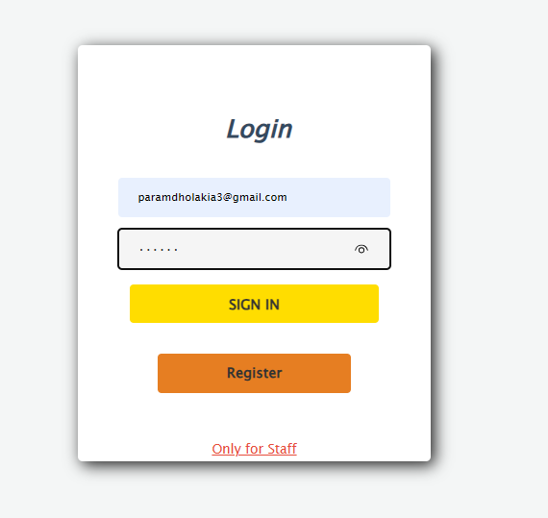

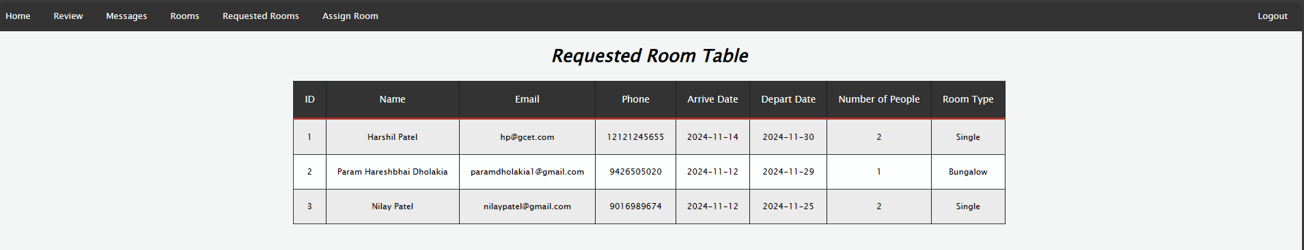

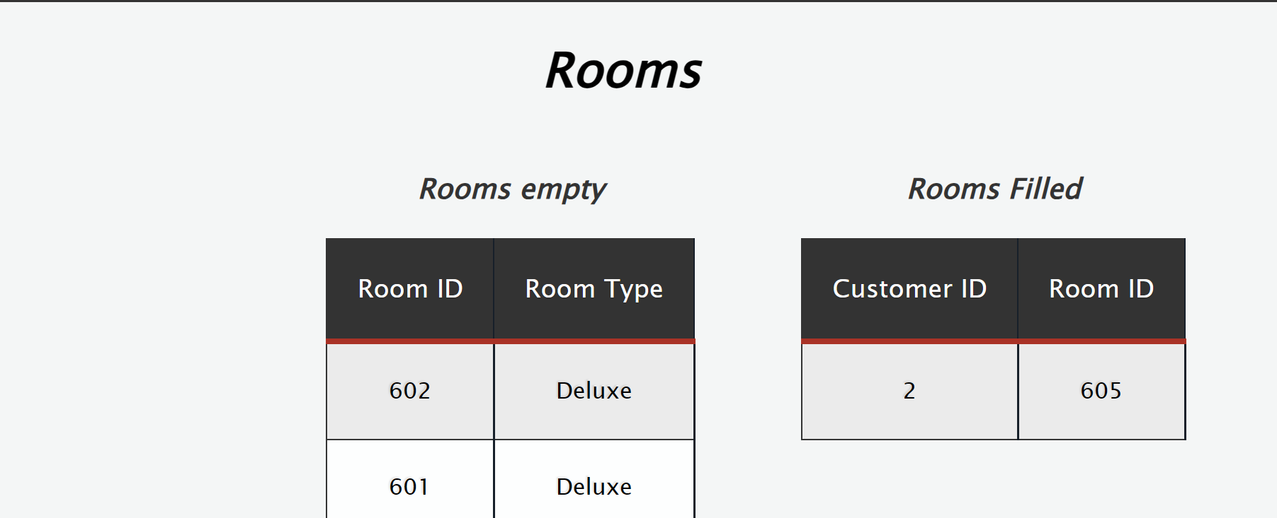

* 1. SEARCH BOOKING

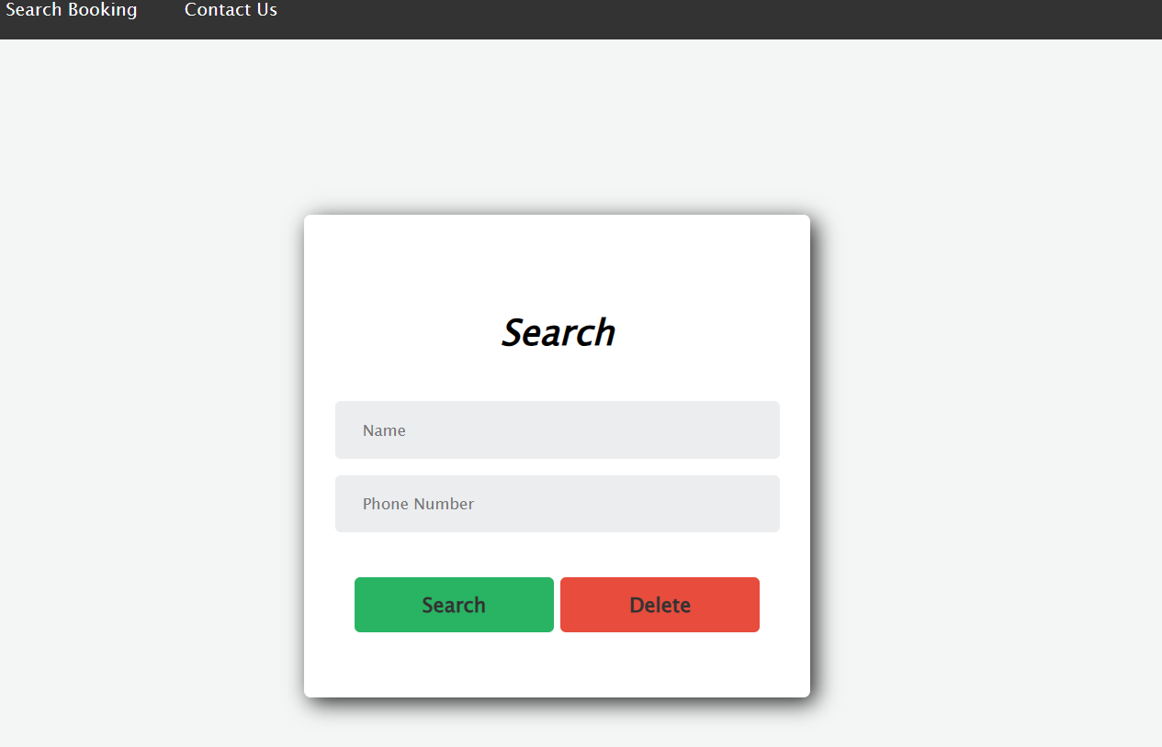

* 1. ASSIGN ROOM

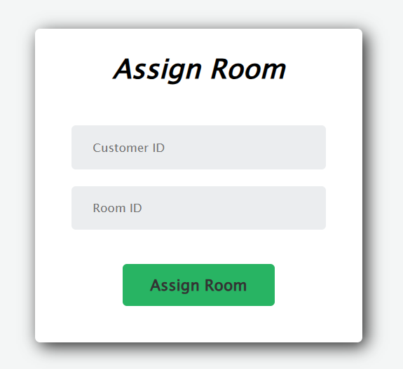

* 1. DATABASE

